ECEN 325

Lab 9: BJT Amplifier Design

Section 506

04/10/2020

Jason Gilman

TA: Mandela

**Calculations**

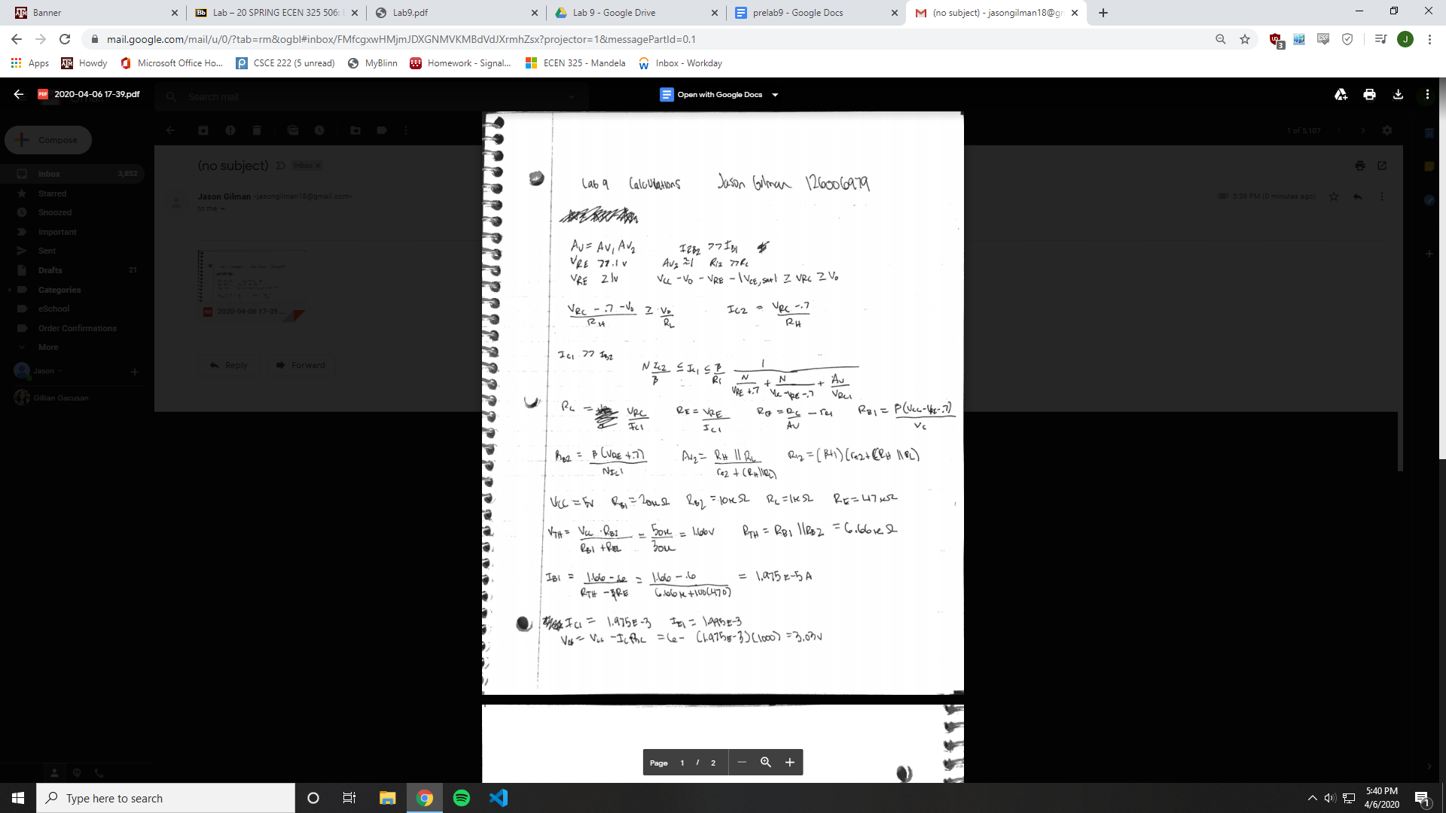

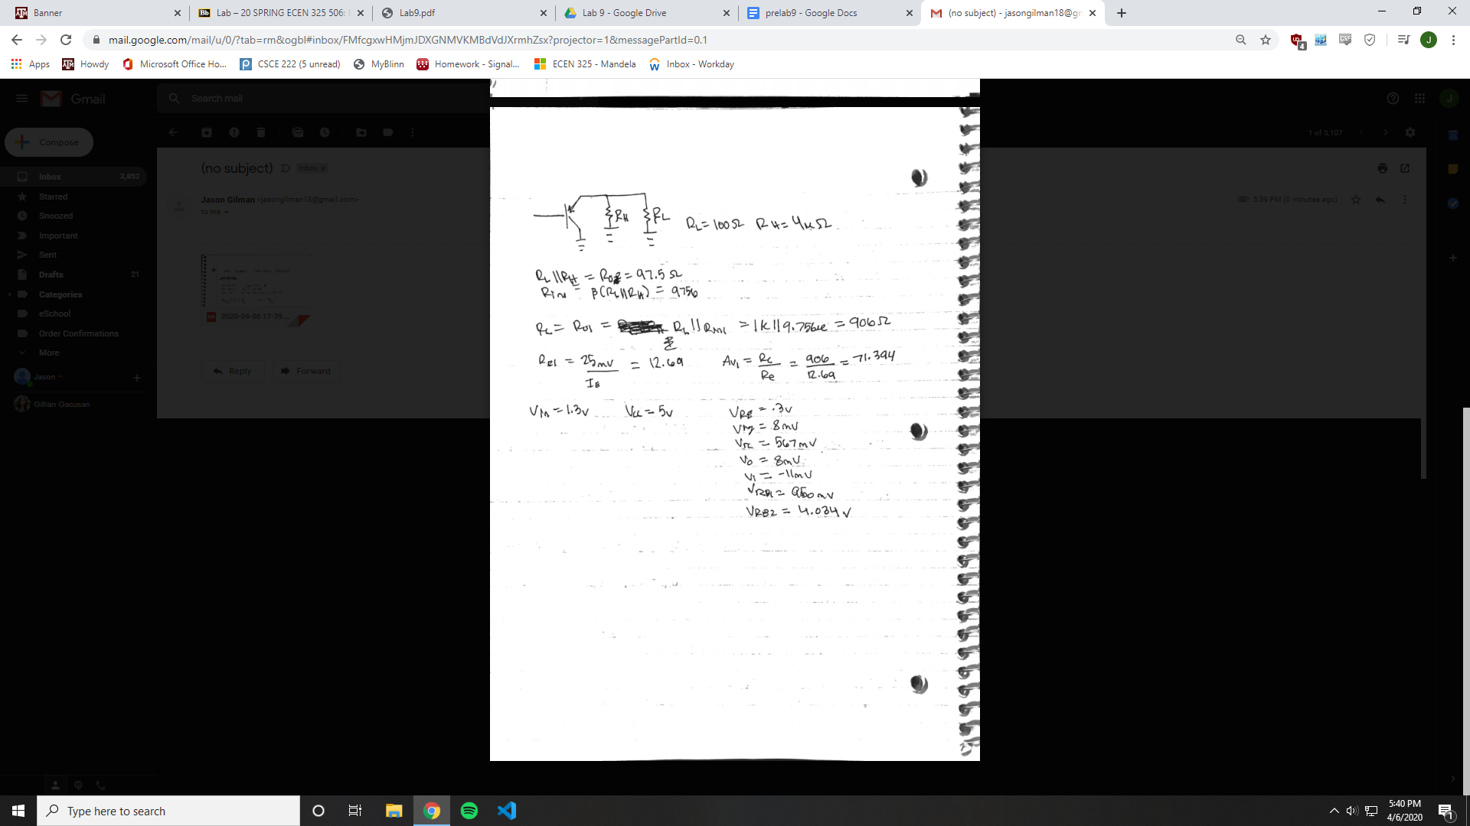

**Simulations**

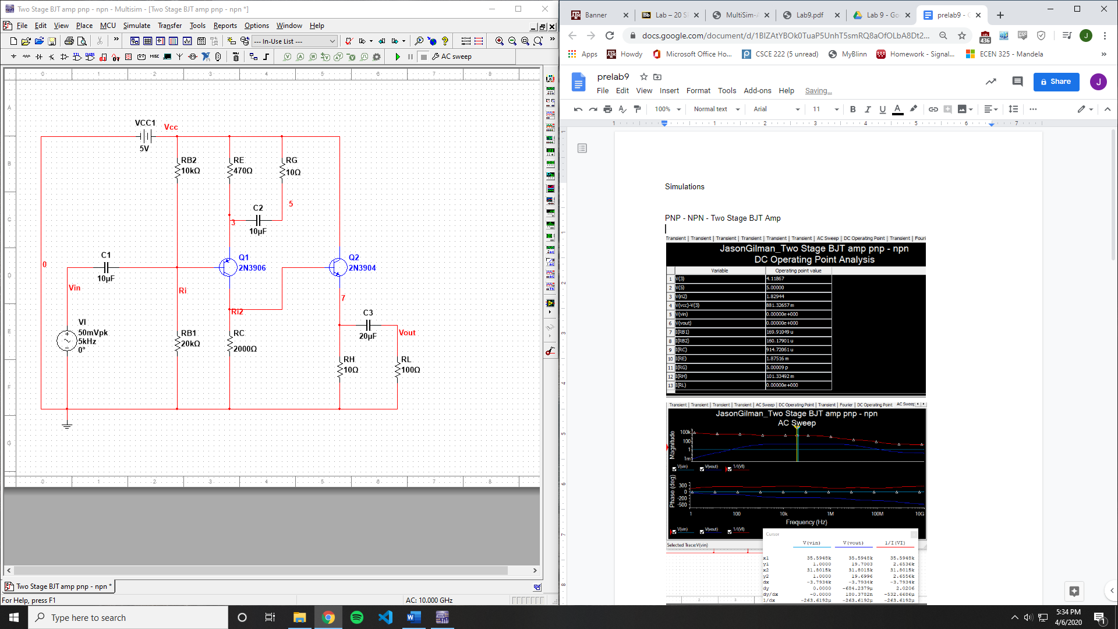

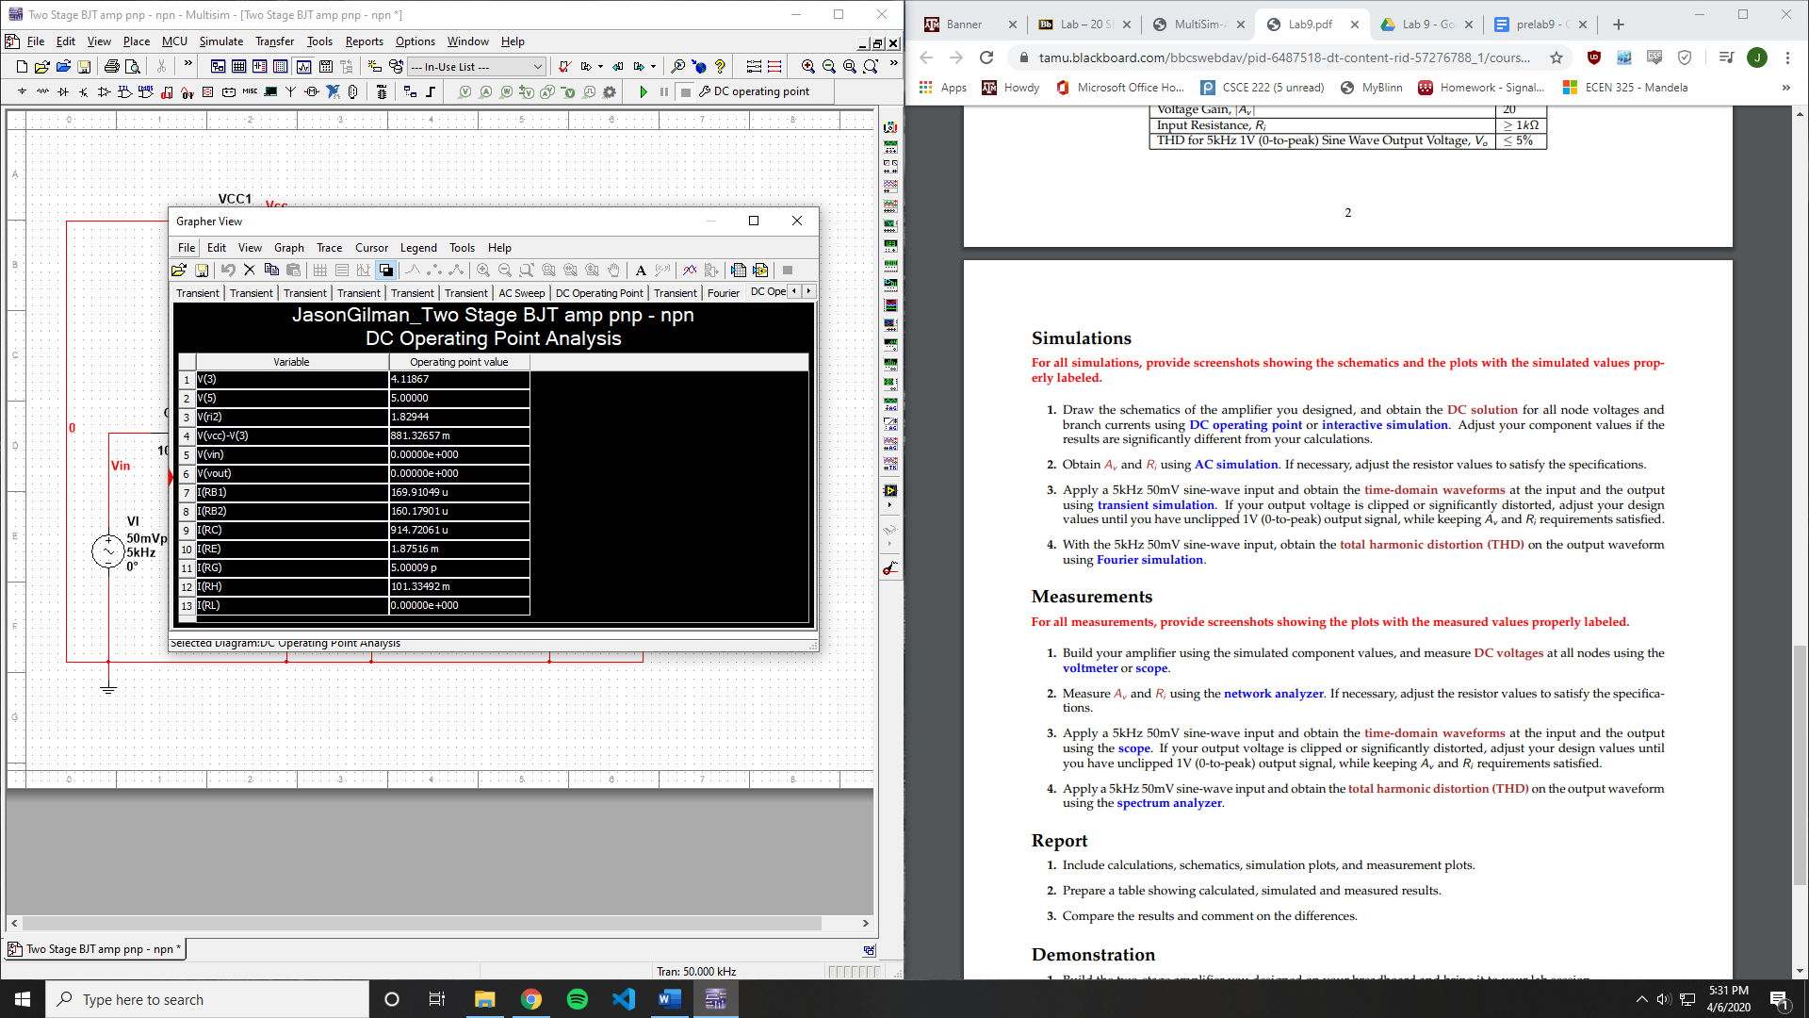

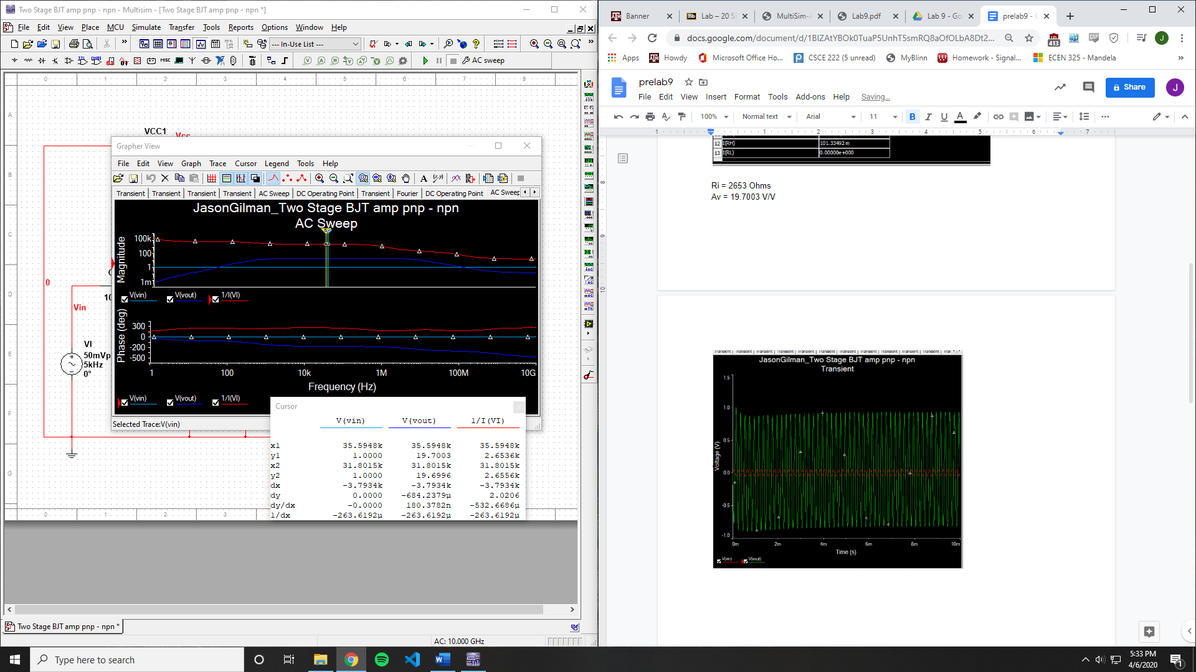

Ri = 2653 Ohms

Av = 19.7003 V/V

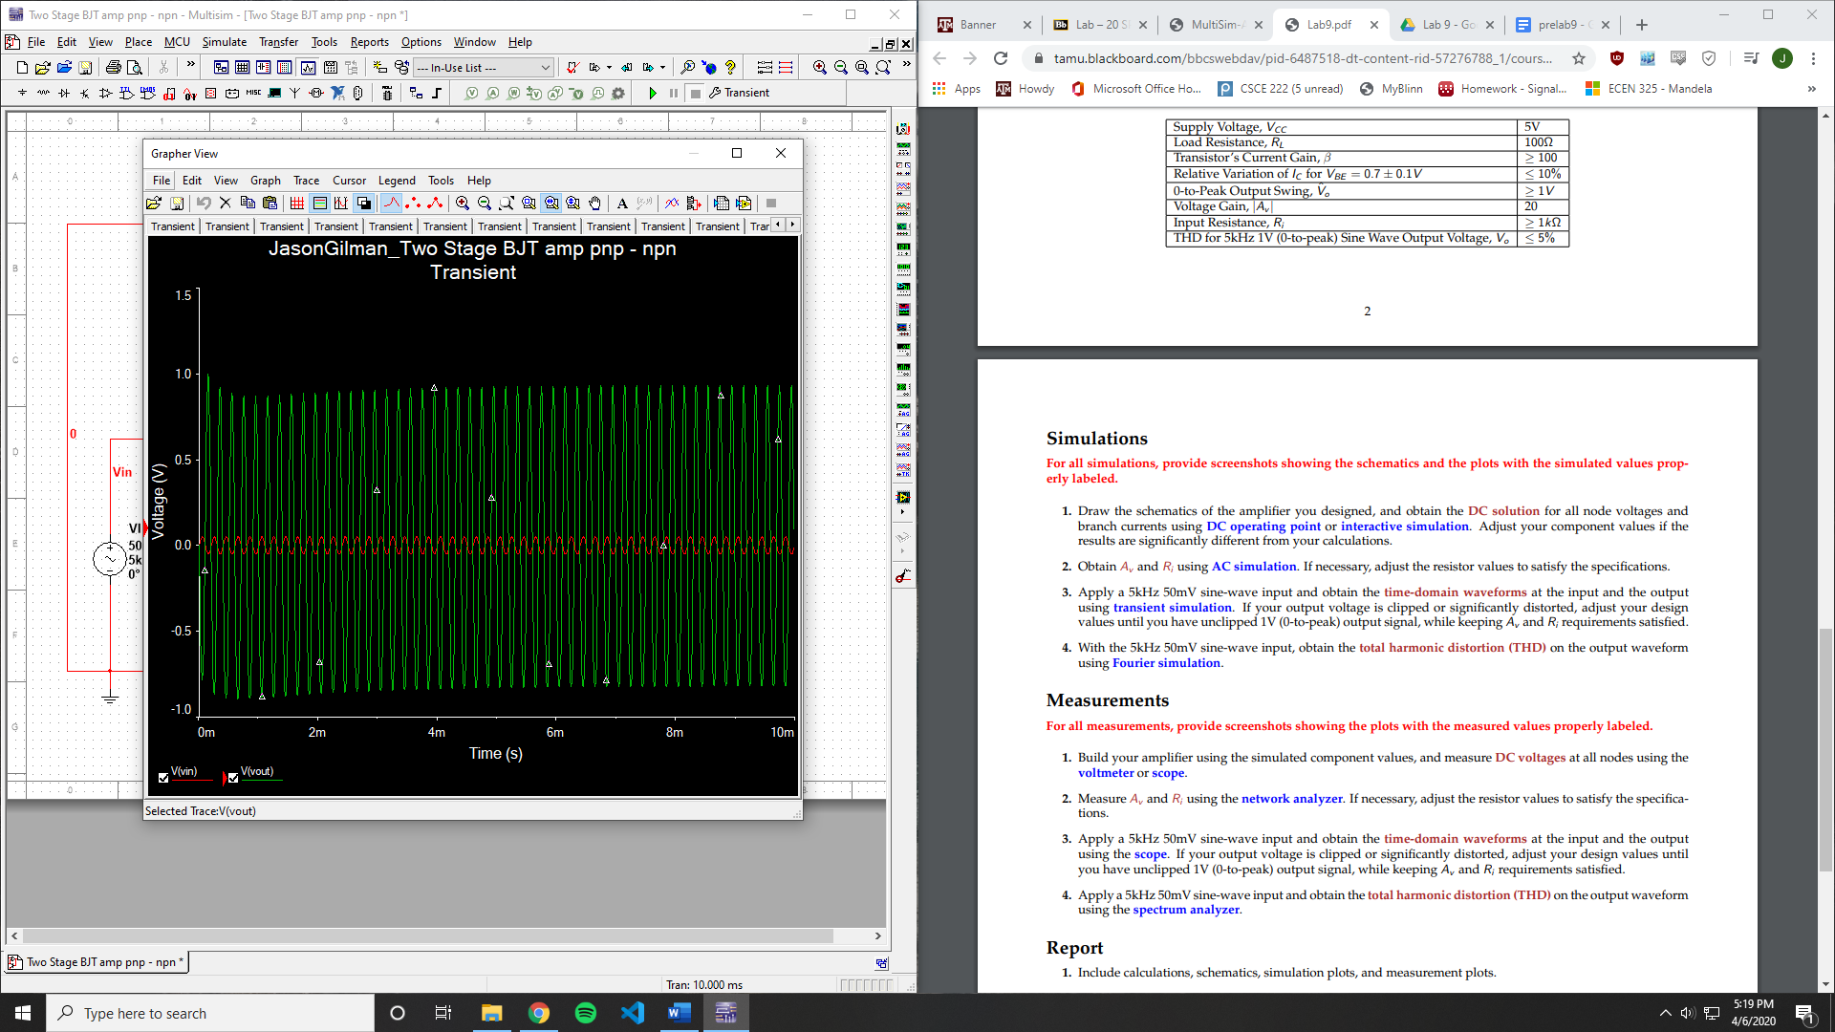

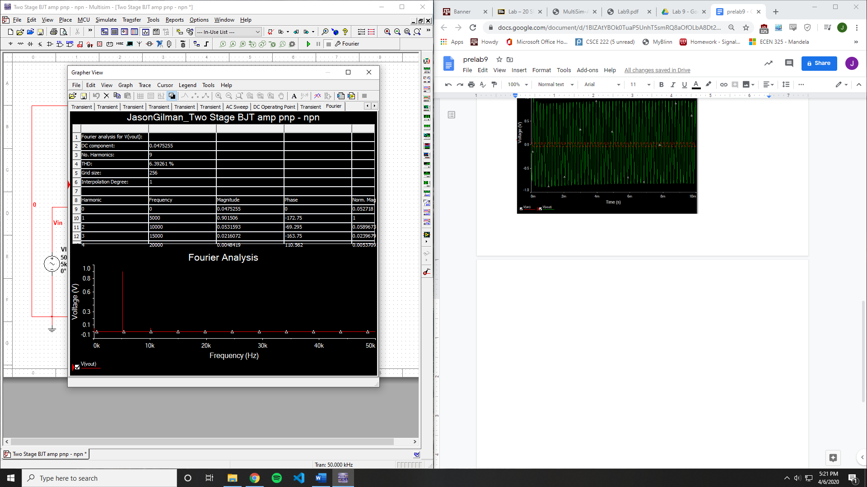

THD: 6.39261%

**Measurements**

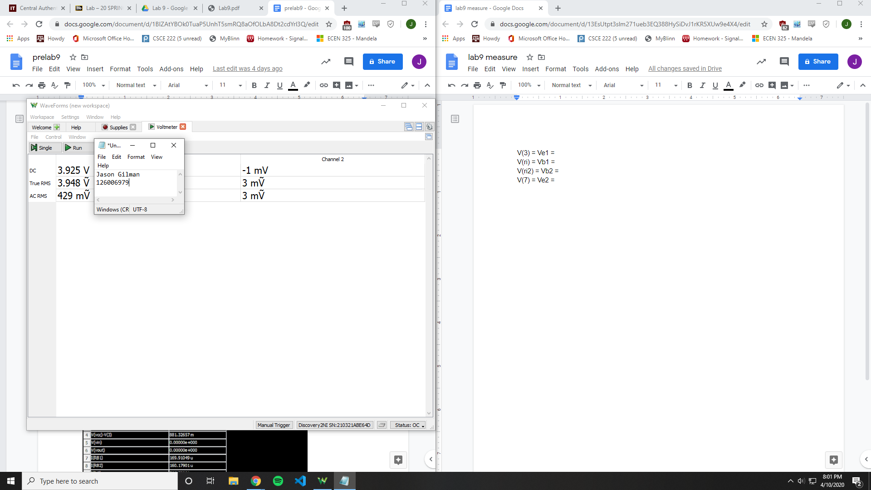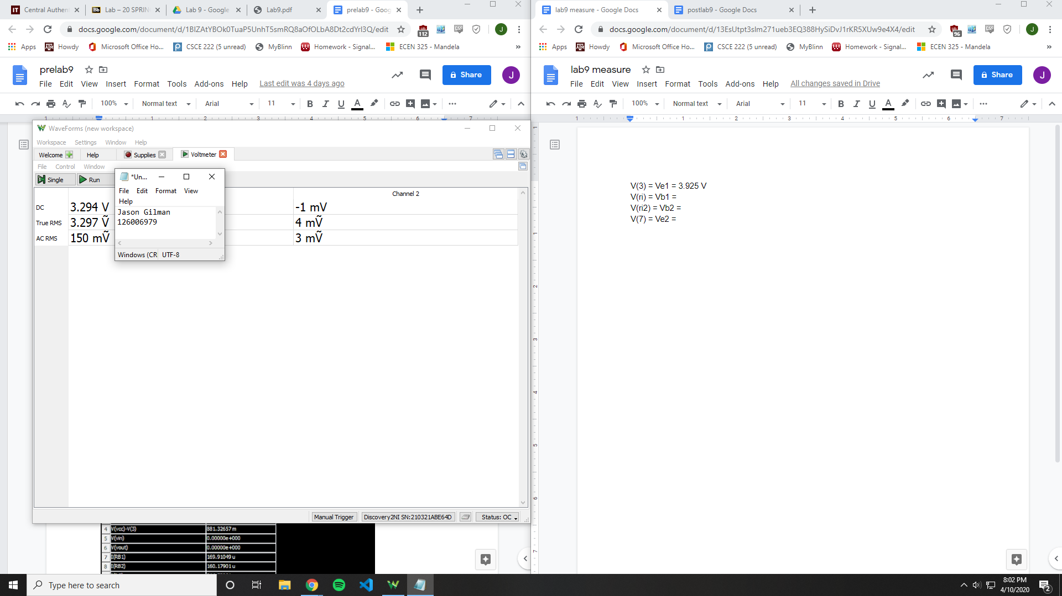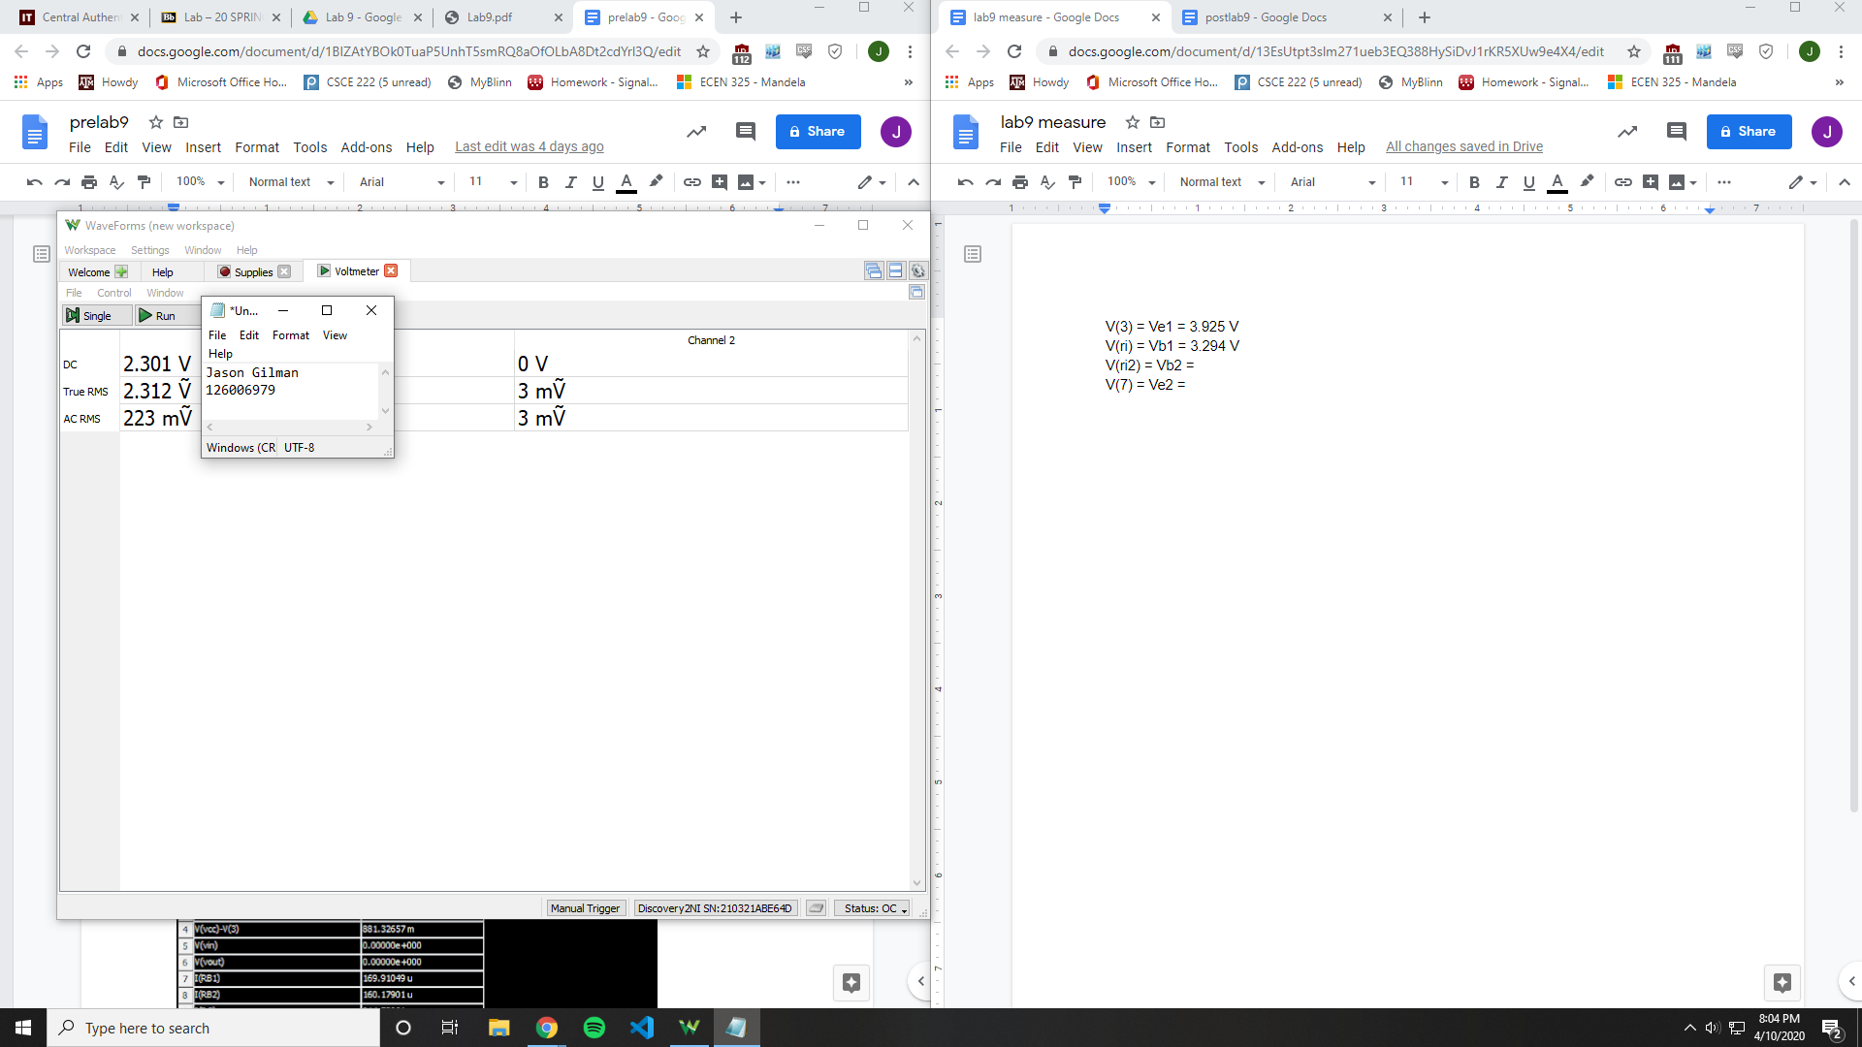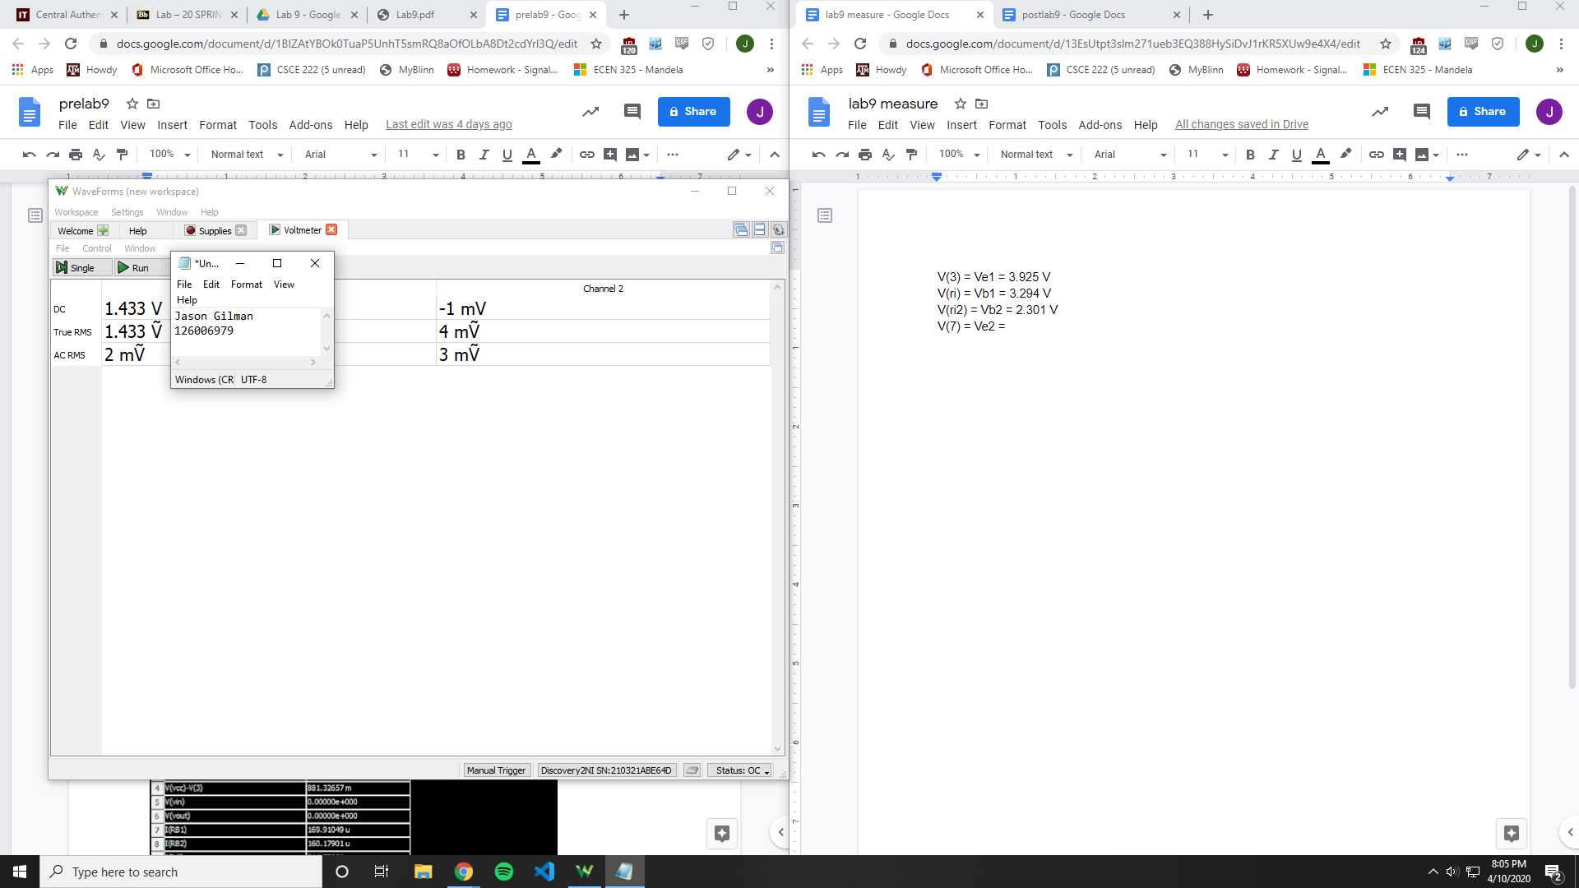

V(3) = Ve1 = 3.925 V

V(ri) = Vb1 = 3.294 V

V(ri2) = Vb2 = 2.301 V

V(7) = Ve2 = 1.433 V

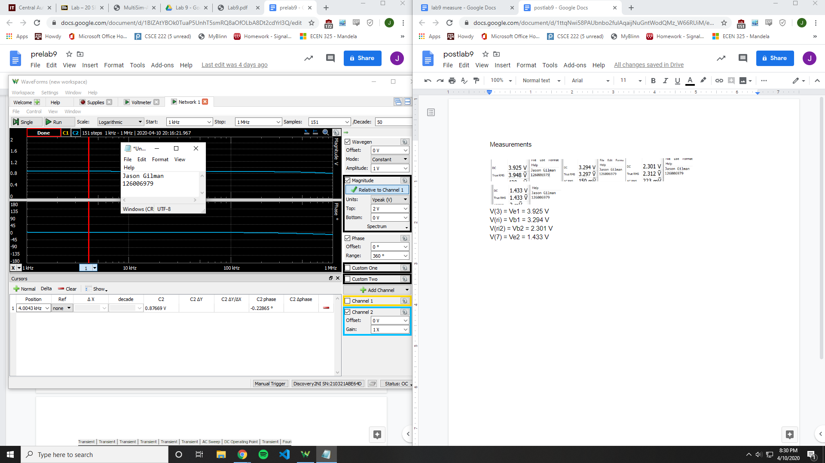

Av = 18.3403 V/V

Ri = 7109.64 Ohms

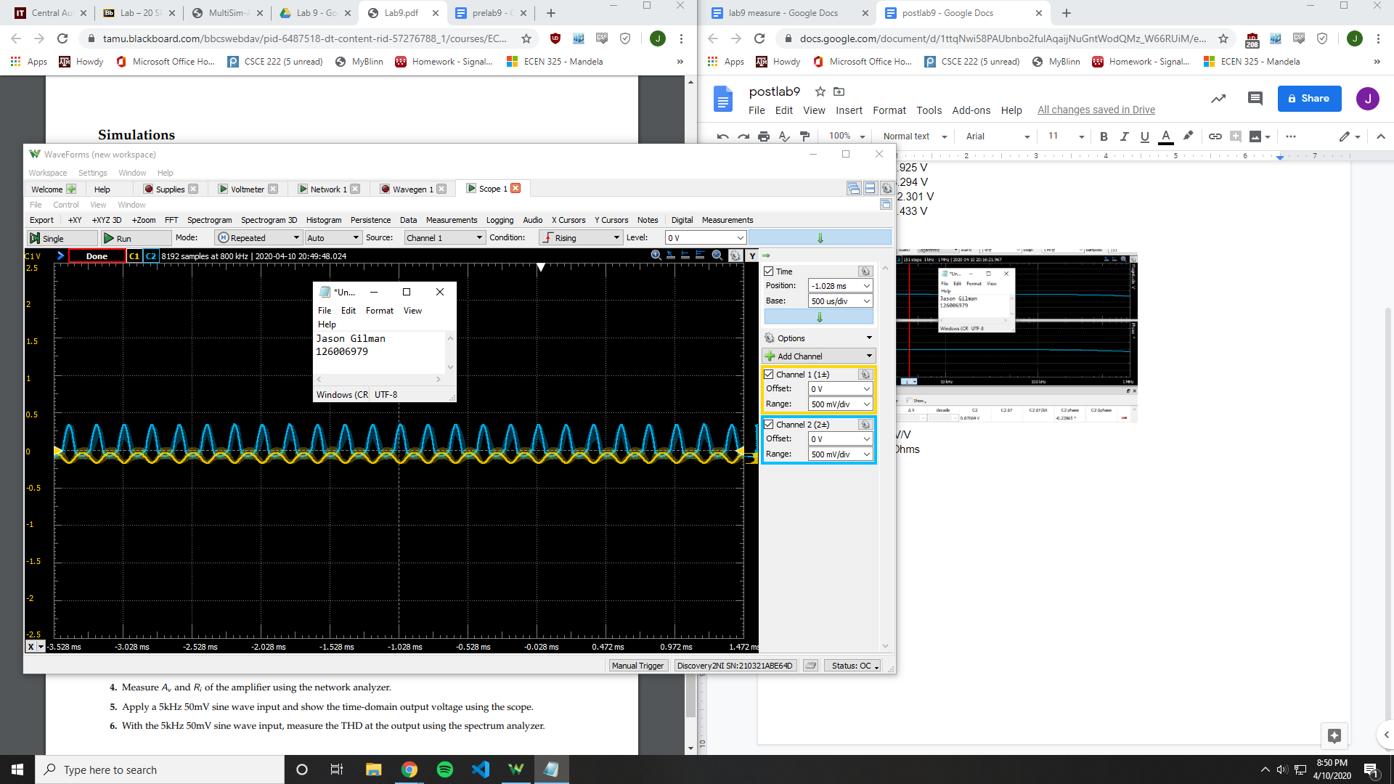

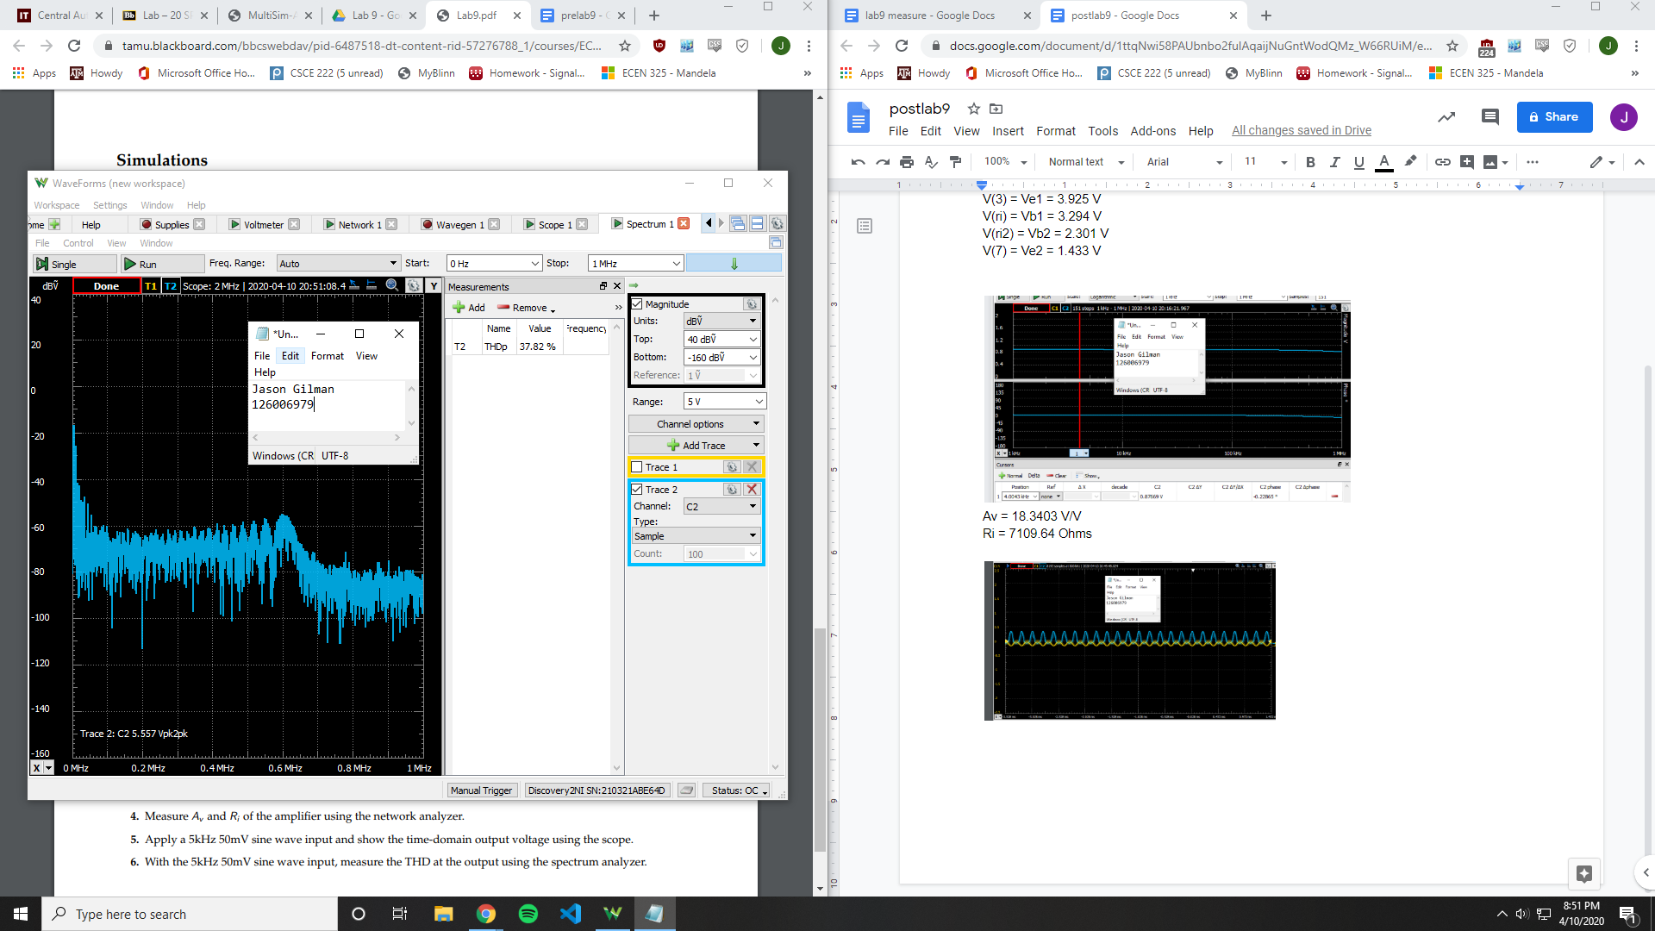

THD = 37.82%

|  |  |  |  |
| --- | --- | --- | --- |
|  | **Calculated** | **Simulated** | **Measured** |
| **V(3) = Ve1** | - | 4.11867 V | 3.925 V |
| **V(ri) = Vb1** | - | - | 3.294 V |
| **V(ri2) = Vb2** | - | 1.82944 V | 2.301 V |
| **V(7) = Ve2** | - | - | 1.433 V |
| **Ri** | - | 2653 Ohms | 7109.64 Ohms |
| **Av** | 71.394 V/V | 19.7003 V/V | 18.3403 V/V |
| **THD** | - | 6.39261 % | 37.82 % |

**Conclusion**

This lab was difficult to produce the exact results from each stage of measurement. Going from the simulations to the measurements, many of the values are different. This could be due to the sensitivity in the BJTs.